Ideation Phase

Define the Problem Statements

|  |  |
| --- | --- |
| Date | 10 October 2022 |
| Team ID | PNT2022TMID43466 |
| Project Name | Emerging Methods for Early Detection of Forest Fires |
| Maximum Marks | 2 Marks |

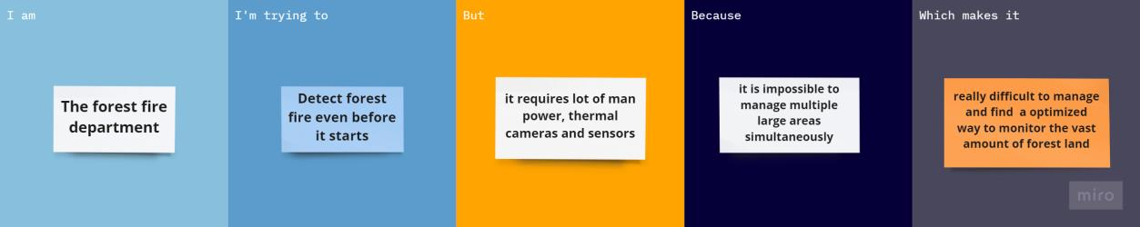

|  |  |
| --- | --- |
| **Problem statement** | Forest fires are a major environmental issue, creating economic and ecological damage while endangering human lives. There are typically about 100,000 wildfires in the United States every year. Over 9 million acres of land have been destroyed due to treacherous wildfires. It is difficult to predict and detect Forest Fire in a sparsely populated forest area and it is more difficult if the prediction is done using ground-based methods like Camera or Video-Based approach.  Satellites can be an important source of data prior to and also during the Fire due to its reliability and efficiency. The various real-time forest fire detection and prediction approaches, with the goal of  informing the local fire authorities. |
| **I am** | The forest fire department |
| **I’m trying to** | Frequently monitor any forest fire outbreak in the forest, through heat maps and sensors |
| **But** | Its not automated requires lot of man  power, thermal sensors and cameras |
| **Because** | It is impossible to manage a vast amount of forest cover simultaneously |
| **Which makes it** | Really difficult to manage in case of a forest fire outbreak |